Stanley Meyer Steam Resonator Version 2018

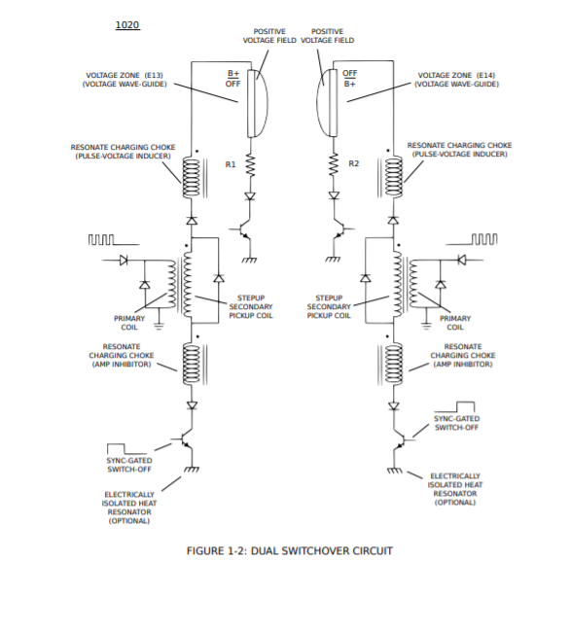
From what I've learned about the AM signal is that it acts as a Wave–particle duality. This vibrates the molecule! Tony Wood Side
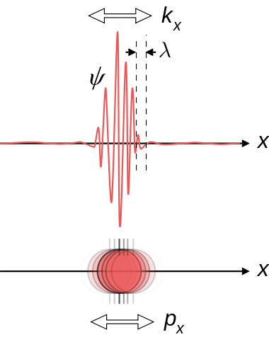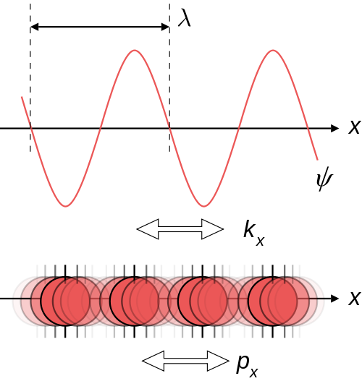

Thanks for the clarification.
I will input 5V square waves and see what happens.
The transformer - it looks like a 1:1 - is that right?
Also, wouldn't some diodes be needed on the output to cut down the back EMF and
to protect the TIP120's, or is that what we are after?
I will try a few different ones to see which works best.
Wouldn't it be great if I could get some hot water!!
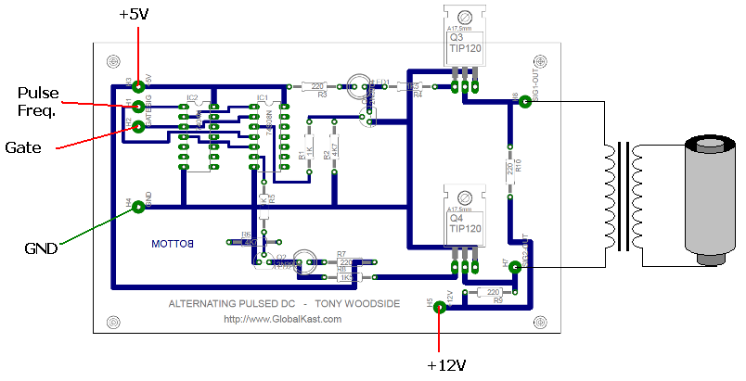
Interesting water-gap!
Stan Meyer 0.0950 inch = 2.4 millimeters
Peter Davey 0.0826 inch = 2.1 millimeters
Looks like Peter used "Three" frequencies: 350, 49, 1000Hz
So there must be a "key note" for the water molecule and use this fundamental frequency and put harmonic on it or enharmonic ?
http://www.ionizationx.com/index.php/topic,1305.msg22201.html#msg22201
Note:
If you have a fundamental frequency (sinewave) and then put a harmonic (sinewave) on the fundamental we get a new shape.
"There are several important aspects to this new shape.
First, its shape is not a simple sine wave, so it will sound richer than just a pure tone.
Second, even though the shape is different, the period and frequency are the same as the fundamental above.
This is very important, because it means that the pitch stays the same.
So, now we can see the connection between shape, harmonics and tone quality.
If add harmonics to the fundamental, we change the shape of the wave, but not its pitch, so this gives us a way of independently controlling the tone quality without affecting the pitch. It does not matter if we add a wave at 3f, 7f, or 32f. The shape will change but the pitch will not."
Br,
Webmug

Circuit explained:
The transistors are configured as an H-bridge.
This series of transistors will take 400 volts.
T1 is a 1:10 step-up. T2 is the choke coils bifilar wrapped similar to the 8XA.
The bridge diodes should act as the blocking diode.
The CD4047 will deliver a near perfect 50/50 pulse.
The only thing I’m not sure of is the value of the bias resistors for the transistors,
and the overall frequencies.
I plan on winding the coils on a large ferrite U core, probably with 18 gauge wire.
The last thing I am trying to understand is if the steam resonator tubes were part of an open circuit or a closed circuit. A transformer will still provide voltage in an open circuit. One of Meyer's drawings shows the tubes connected to ground making a complete circuit so I'm not sure. Or does the water act as a ground?
What do you guys think?
Re: Figuring out the Steam Resonator
Yes, this is confusing to me also HMS, Stan's document shows a separate ground for an optional 'heat resonator'?
The ground seems to be separate from that of the primary and driving circuitry.
I have built that circuit with many variations, and got no results.
I believe Stan left something out intentionally, for patent reasons.
Below is a pic from my scope using Tony's alternating dc circuit which is supposed to heat the water, but so far the only thing it heats is the two 220 ohm resistors, and they get HOT!
The scope is connected at the secondary of the transformer, across the cell.
Water is distilled. Scope is set to 5V / div, so the signal amplitude is approx. 20V.
I am certain the fault lies somewhere in my transformer construction, which only Tony knows how to build correctly.
My transformer consists of approx. 600 turns 29AWG magnet wire primary and 3000 turns 29AWG magnet wire secondary, on a ferrite rod with permeability of 200.
It can't be anything else, because the waveforms and circuit seem to be working correctly...
I am not giving up though - each day you fail is one day closer to success! o, from what I have learned there are a few ways you can build the steam resonator.
-You can use Tony's circuit which is kinda like a halfbridge driver.
-You can build a fullbridge driver to switch the polarity at the primary coil
-Or you can switch the polarity directly at the resonator.
Switching the polarity at the secondary side (directly at the resonator) gives the most flexibility as this way you can drive the coil at a constant frequency. This way changing the switching frequency will not change the impedance of the coil, and you can switch the polarity as fast as you want. I'm not sure if Meyer used 'Dead time' between switching or if that was why he had those high watt resistors to prevent the short circuit during the swictching overlap. The Tech Brief diagrams do show dead time though. Trying to figure out how to add it to the driving circuit???
the steam resonator is a follow up project of the WFC application. once the VIC works the right way the operational chain of secondary, chokes, diode and electrodes can be doubled and space between both electrodes can be changed. that way no hydrogen is produced and therefore there is no need for an EEC in this application.
don´t be fooled by the GND signs - they are isolated so that there is no real GND at all. you can take "Off" as negative potential "B-"
the circuit works the following way:
each electrode can change it´s state between positive voltage field and "GND".
that way ions have to travel around a lot in the water bath heating it up by the way. the true value is the VIC doing it´s voltage potential work with minimum amount of amp flow.
both mirror side circuits are operated anti-cyclic.

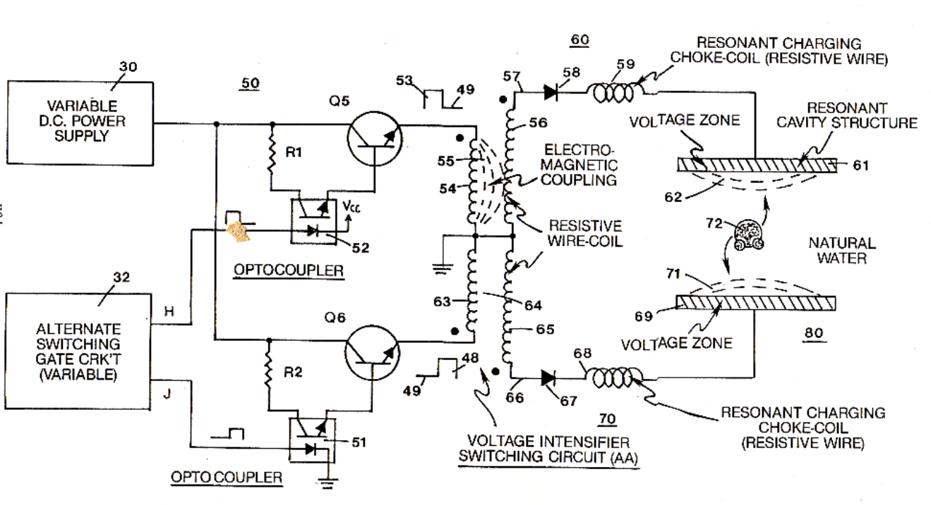
Heat/Steam Resonator (element) Stan Meyer style circuit test @ 90VDC, 1A, 1.2 KHzWe are testing this element for the home heating boiler. Heating up 1 liter of water from 15 Celsius to 90 Celsius in 1 second is faster than a magnetron. The element used in this test is "3XXX 3#INCH". We are using a new circuit for this test.What we are doing is testing a circuit at various frequencies and voltages at low amperage to find resonance and to quickly heat the water.The reasons why you would need a "heat resonator" is, for example, to defrost the fuel tank, with water as fuel, in the winter if it is frozen. We would also use the "heat resonator" in a home heating boiler to heat up the water and pump it around the house to have a warm house in the winter. In Europe, we use a lot of propane in the wintertime to warm up our houses.
once the VIC works the right way the operational chain of secondary, chokes, diode and electrodes can be doubled and space between both electrodes can be changed. that way no hydrogen is produced and therefore there is no need for an EEC in this application.don´t be fooled by the GND signs - they are isolated so that there is no real GND at all. you can take "Off" as negative potential "B-"the circuit works the following way: each electrode can change
it´s state between positive voltage field and "GND".that way ions have to travel around a lot in the water bath heating it up by the way. the true value is the VIC doing it´s voltage potential work with minimum amount of amp flow.both mirror side circuits are operated anti-cyclic.as Meyer said: it´s all about timing

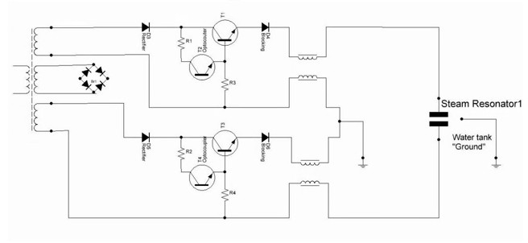
its definitely a h-bridge circuit ( seems they are used for dc/ac sinewave inverters and dc motor controllers)
I'm very much a novice on this, but the signal to control the transistors can have two parts, one for pwm and the other for gating? I'll do some more work on matching stans built circuit and matching it to valyonpz circuits, I think he is on the right track.

I think that the 12v/240v converter is also switching between coils, one coil on the other coil off,
the optocoupler driven by dual 555 circuit or similar same as the resonant cavity cells,
and bifilar? chokes also. Interesting the water bath used as earth so any time one plate is not powered. I think valyonpz may well be correct, i'm not electronics expert so maybe some other guys here can figure out circuit component parts/values so that it can be built?
The pair of transistors appear to be darlington optocouplers like these:
https://www.sparkfun.com/products/314
But the resistors in the schematic look wrong. Maybe the circuit is entirely designed to do something else.

Always remember me on that circuit. Look at the hot water switch....
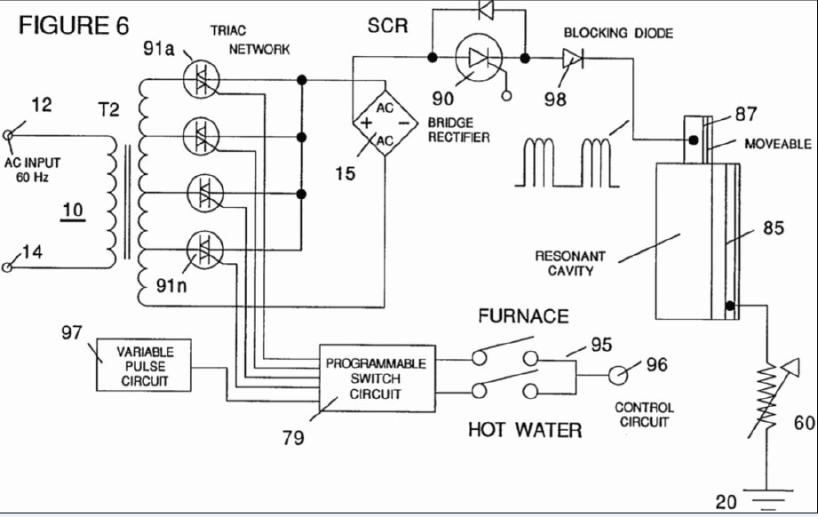
thnx for posting haven't seen that circuit,
the transistors ( sk3181a/sk3180) first is 40v, second one is 80v, they seem to be connected to the high voltage coil wires, if they are stepped up from 12v to 240v by 20:1 from primary to secondary they seem to be underrated for the voltage? Hey. The circuit is in an old patent of Stanley Meyer.
You see no charging chokes or whatever. It looks like a voltage selector, in the patent is descripted, that the hot water switch activated higher voltages.
Maybe some pre designe of the Steam Resonator.

just messing with reverse engineering stans hbridge:
put some coloured lines on these two diagrams ( and labelled the transistors in detail)
first diagram is what stan built, second picture is matching it to valyonpz h-bridge diagram
( very difficult to go any further unless the transistors are insulated from the aluminium plate that is putting all the collectors of transistors onto a common electrical connection, still plenty of mystery to olve on this one)
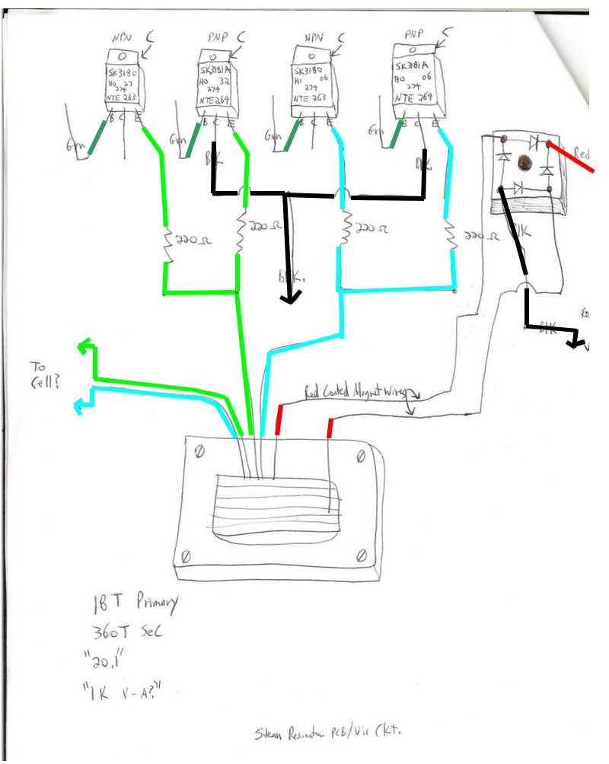
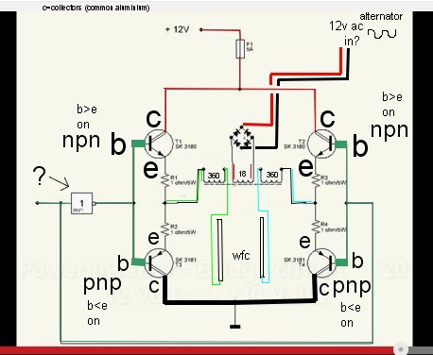

Maybe not a converter to 120V/230V, but to 70 or 60 or something like that. The amperage would be much too high with 120V. I tried this several times.
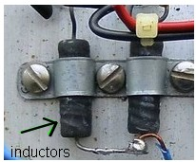
Above a closer look at what had been labelled as 'resistors' on an interpretation of stans board,
you can see the thick windings under the black heat shrink/plastic, so they are inductors rather than resistors, so max millers interpreation of this being a power supply board might be correct?
=========
If those are chokes, where did the 220ohm measurement come from? if measured from the "chokes" they must be wire wound power resistors, because you can't find a choke like that with that high of resistance. The fuse is your power coming into the circuit, the chassis is ground, and those transistors don't have the collectors connected to the heat sinks internally, so heat sink pads not issue (metal mounting screws would be an issue too, so nylon screws would be used because non-conductive). lastly, what you think is the cell output, looks like the primary center tap to me(either normal center tap or bucking coil center tap), and that rec bridge you think is connected to alternator is really the cell output. In his schematics he shows another switch on the HV positive side, but most likely the primary switching accomplishes the same kind of signal on the secondary, from the primary "switching noise" which normally would be smoothed out with a capacitor on the output : (Kept It Simple, Stan) .
push pull converter
Transformerless Push-Pull
Class AB power amplifier. (P.S. We don't need to worry about "cross over" distortion with DC pulses!))

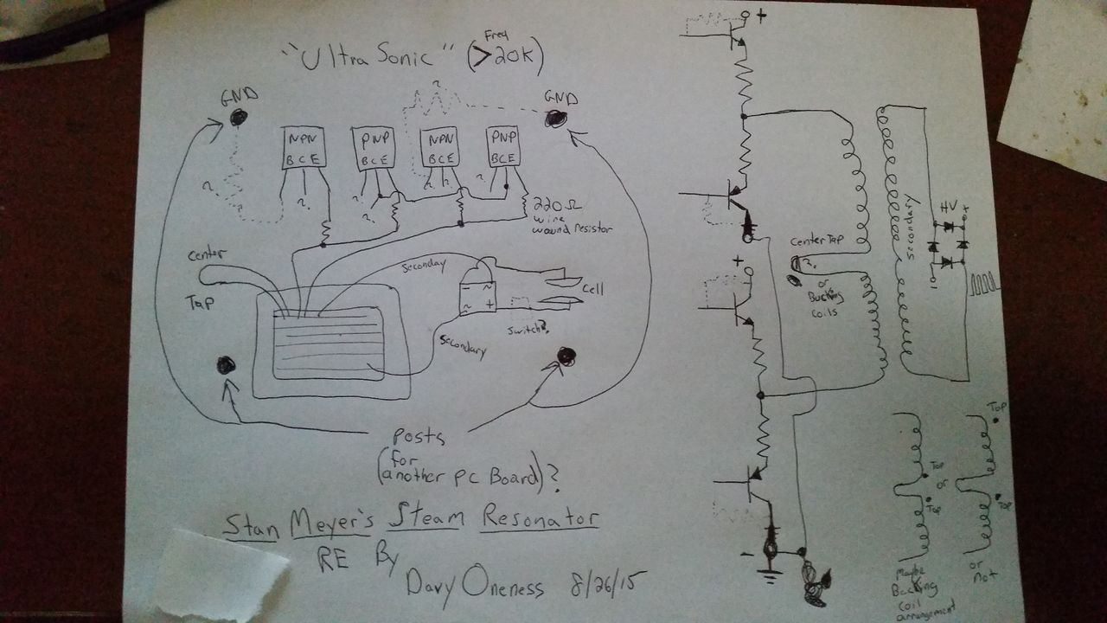

http://s12.postimg.org/5u6ucorf1/20150826_143648_1.jpg
Also note: If his memo's mention "amp restriction" than the primary most definitely bucking coil arrangement. But easy enough to test once you have it set up on your bench.

Looking at this just now, and I now think what I was calling the center tap, is really the feedback coil. The card has a "lock" LED for resonance just like the VIC, so would have same circuit for that part also.This makes more sense to me with the full "push pull" style driver .
:cool:
Here is what I see now:
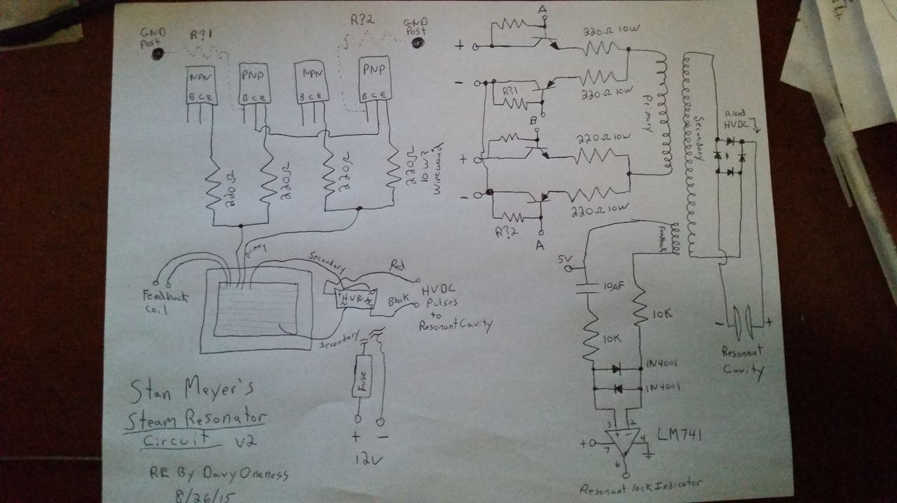

Ok, based off of studying Stan's schematic for the VIC driver, this one I just drew up for the steam resonator should work quite nicely!
:cool:

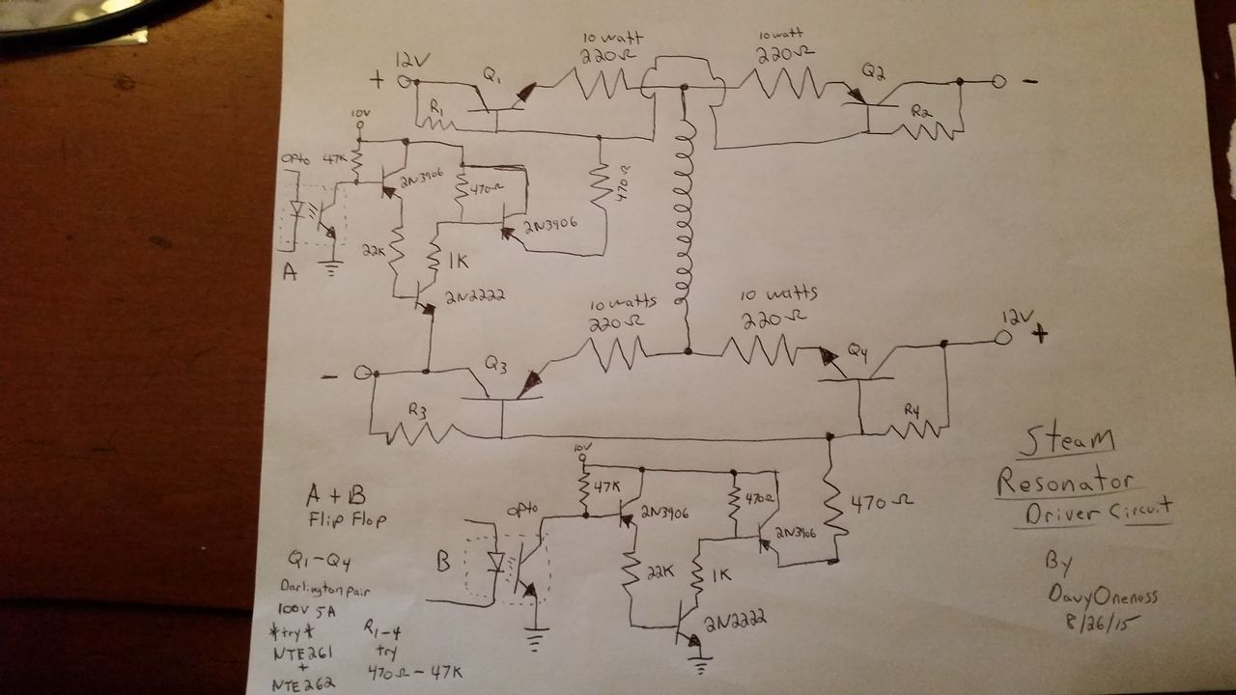

http://s29.postimg.org/mpuo24mx3/20150826_192207_1.jpg
Use a separate 10volt supply through a volt regulator to switch driver, don't use the same 12v driving the coil because a HV spike may fry a transistor in the amplifier's input.
On second thought looking over this, I don't think R1 and R4 are used, and 470 ohm maybe best for R2 and R3
Stan using a pull down trigger to pulse the driver, is like having a loaded spring with a hair trigger release and a rapid recoil reset. As opposed to the way everyone has been trying to trigger all their FE circuits, which is more akin to kicking in the trigger with your foot and the primitive trigger mechanism drags across itself, and the spring, adding losses in its recoil speed and power output......then you can only go so fast, and when you do try doing it too fast, the whole operation gets unstable quickly........

thanks davey oneness for looking over the steam resonator, its my understanding that the 220ohmn value came from somenone who measured the 220ohmn on stans device shown in the pics. I cant remember who it was, but someone had access to what was left of stans estate though a fair bit got sold to a company ( not that long ago).
Thats amazing you can understand it, and actually give a circuit that will be testable.
There was one other issue: how it is connected to the water bath, from memory its different to the wfc stainless tubes, which just have inner/outer tube connections. I think the steam resonator had three connections ( someone else might chime in on that ?), I'm really not sure on that, but there was some discussion on how its connected to the water.
My electronics knowledge is not all that advanced, so very much appreciate your input to assist making steam resonator ( heater) circuit replicable.
So would you say the purpose of the circuit is rapid switching of direction of flow of electrons ( or in stans case rapid switching of the voltage polarity with low amp draw), would you think the circuit I was trying to reverse engineer ( with only basic electronics knowledge) is designed to rapidly heat water? Some had suggested this was merely a power supply and not involved in water heating?
I think you have made a large contribution to understanding this bit of meyers work.

THIS IS WHAT I AM SEEING NOW

The triac network selects the higher through lower voltages from the secondary winding taps (your throttle control for heat), In this picture, the transformer is fed with 60hz AC, and the rectifier bridge turns that into HVDC, and then the SCR pulses it to the plates.
In the one I just reversed engineered, you can see the switching on the primary that the HV SCR would be doing, and the signal through the bridge rectifier would produce the same pulsing to the plates from what would be called "DC Ripple"
Lastly, the amp restriction in these was done by using stainless steal wire for the secondary (high resistance) looking at the secondary winding before, the way it is sectioned, the winding may reverse direction every little section to act like the bucking coil chokes on the VIC. BUT NOTE, the transformer from the estate we are using as ref, looks like plain old copper magnet wire! It may also be possible to use a normal transformer with the bucking chokes set up at the plates like on the VIC.
Oh, and the dune buggy had a plastic water tank, so no case grounding. I think the case ground was for a dual plate, and this one I RE is an alternating single plate.
And one last thing, I don't think the signal is gated like on the VIC , it shows it in this picture, but was watching this video on using resonance to explode virus (like rife) and he specifically stated, that without a gating frequency the samples would just heat up and not explode.
Stan's control panels have no controls for adjusting duty cycles for ANY of the cards, in the same virus video, He said all the successful resonant shattering had one thing in common, the main freq was the 11th harmonic of the Gating frequency! So no need to adjust that, just tune the main freq, and the gate is automatically adjusted to harmonically match !

https://youtu.be/1w0_kazbb_U?t=7m5s

I understand now why the plates of the steam resonator are also stainless even though no hho is present. This is the same reason he uses stainless steal in his secondary windings, it is for the resistance!
"In a non-electrolytic capacitor and electrolytic capacitors with solid electrolyte the metallic resistance of the leads and electrodes and losses in the dielectric cause the ESR. "
Equivalent series resistance (ESR)
Capacitors in electronics fail over time because the electrolyte (conductive part) dries up and the ESR goes up and it heats up (causing the ESR to go higher) from ripple currents hitting it (sound familiar?) until the gasses from the heat expand enough to explode the capacitor!

"The higher the ripple current, ESR, and thermal resistance
between the capacitor and ambient the higher the temperature
rise of the capacitor. The temperature of the capacitor is di-
rectly related to failure rate—the higher the temperature of
operation the higher the predicted failure rate. Ripple current
has no other detrimental effect on the capacitor beyond rais-
ing its core temperature"
http://www.newark.com/pdfs/techarticles/kemet/Ripple-Current-Capabilities-Technical-Update.pdf
After some experimentation, it is clear to me that one of the plates needs to be insulated to prevent electron flow and make it as Stanly puts it, an " ideal capacitor" .I experimented with the set up without plate coatings, and the water just becomes electrified from current flow. Stan states for one cell the water has a resistance of 75oms(also states salt water can be used without problems even though even more conductive), so clearly the water is not the dielectric part of these capacitors. Instead the water is an extension of the negative plate while the positive electrode is insulated. In early stan prototypes, and xogen demo, the plates must be done with clear coat polyurethane, I think. The proof of all this is in Stan's car plug which is as he states,is a miniature compact version of his whole system, and the positive electrode has like 2mm ceramic insulation to prevent the current flow through in order to set up the electrostatic field for splitting. Why ceramic? because the poly is only good short term because of Ozone produced in the process will degrade the coating over time! So all those replications with "conditioned plates" was about discovering that the plates need an amp restricting coating, but don't do both pos and neg! Because I am pretty sure the Neg isn't insulated for best results. Wonder where people like ravi and lawton at these days, my guess is they are keeping their results private now that they found the key. It is getting cold here, so not sure if I can get my plates coated to continue till spring, so hopefully someone can pick up and share until then, that is if there are any experimenters left around here.
referring to secure supplies attached doc ( modulators.pdf),
figure 3-33 is interesting in that it shows a capacitor with an inductor on each side, the text going with that picture has a very detailed explanation of how it works. Its beyond my understanding but might prove useful to others. It is an equivalent circuit of fig 3-32, it discusses saturation of the coils and resonant condition charge transfer, also current limiting. It may well be directly relevant to understanding stans circuitry.
referenced here for thought
I too am fascinated by Meyer's ability to superheat water using voltage and not current.
We CAN DO THIS!
Keep up the good work all.
I am working on extracting the circuit from the pics of the home steam heater unit.
Wish me luck.
What threw me for a loop is the bridge rectifier on the 'steam resonator' transformer heatsink.
It sure does look like a power supply setup, but why were there complementary transistors there - PNP and NPN?
We know the following from that picture:
The Collectors of the two PNP transistors are tied together, and go to a black wire that has been cut.
The emitters of one of the NPN and PNP transistors (the pair to the left) go through a 220 ohm resistor and then tie together to the coil.
The emitters of the transistor pair to the right do the same.
The base connections on all transistors have been cut.
It is almost like an h-bridge of some type, but this is not certain.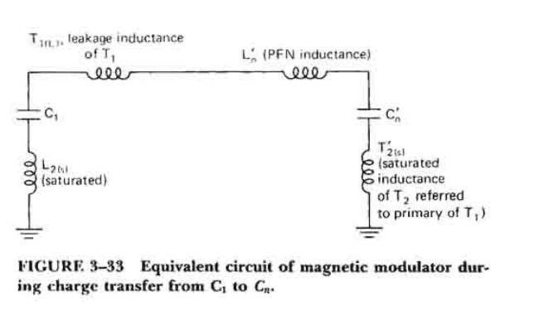

referenced here for thought
I too am fascinated by Meyer's ability to superheat water using voltage and not current.
We CAN DO THIS!
Keep up the good work all.
I am working on extracting the circuit from the pics of the home steam heater unit.
Wish me luck.
What threw me for a loop is the bridge rectifier on the 'steam resonator' transformer heatsink.
It sure does look like a power supply setup, but why were there complementary transistors there - PNP and NPN?
We know the following from that picture:
The Collectors of the two PNP transistors are tied together, and go to a black wire that has been cut.
The emitters of one of the NPN and PNP transistors (the pair to the left) go through a 220 ohm resistor and then tie together to the coil.
The emitters of the transistor pair to the right do the same.
The base connections on all transistors have been cut.
It is almost like an h-bridge of some type, but this is not certain.

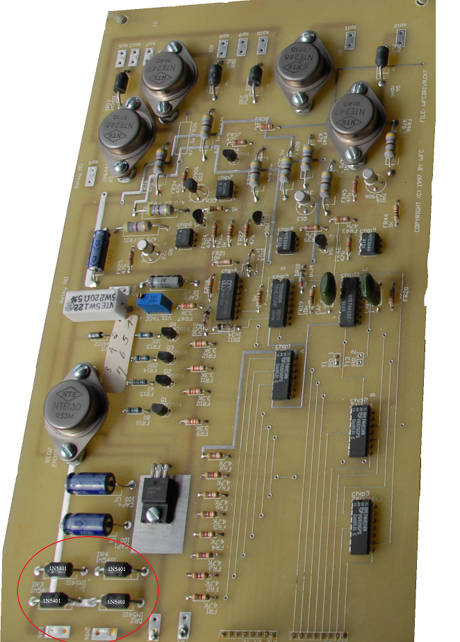

How were you able to find out they were 220 Ohm resistors?
Also,
The H bridge is the same conclusion TonyW and I have accepted after he mentioned it a while back.
It is also why I am confused that stan didn't just use use a push pull circuit at the primary coil?
Also, each Steam Resonator coil has at least 3 seperate coils. It looks like 1 primary and 2 secondary coils.
The plates of the steam resonator do not form a capacitor, they are merely plates in the water in which the current flows through along with the voltage wave. I already have the driving circuit down and wokring, I am currently trying to find a coil which I think could perform the operation of the steam resonator. I think the coil is about the same as the VIC only without the negative choke.
..I think I know know why Stan made the flip-flop circuit on the secondary side instead of the Primary side. If he would have make the flip-flop on the Primary side, it would mess up the resonance, by placing it on the Secondary side it allows resonance to continue during the process. what do you think about this?
Also, the FWB rectifier is connected to the output of the Steam Resonator transformer.
If you have figured out the driver circuit, please enlighten the rest of us.
The resistors match exactly with the 220 ohm resistors on Stan's other vic circuits and photos. He seems to like using 220 ohm resistors with his coils for some reason. Tony & waterfreak
Thanks for the input, the more sides we look at this the better we will all understand it....
I'm still contemplating if resonance was used in the steam resonator circuit? Looking at the home heating unit each switching transistor had a diode which would prevent any series resonance. Also, the steam resonator tubes do not act as a capacitor. If there is resonance it would have to be one of the coils resonating.
Note that in the buggy steam res VIC there were several high watt resistors. I think they were used to limit current but also protect the transistors in case the switching overlapped. The home heating unit used a huge core. Look at how thick the laminations were built up to! This was made for some serious inductance. Imo the inductive reactance of the coil performs current limiting. From my studies I think the circuit is similiar to the VIC, only without a negative choke.
Meyer states in a News Release that the steam resonator is an offshoot of the VIC....In all the diagrams and explanations in the TB resonance is not mentioned. One might think that the term 'resonator' implies resonance but that is a different kind of resonance. When referring to resonant cavities or waveguides the resonance is not the same thing as resonance within a circuit.
Waterfreak...
I should have actually called it the switching circuit, not the driving circuit. I designed a switching circuit on multisim which is very basic. It consists of a 555, a counter, and an RS flip flop to turn on and off the polarity switching transistors. Anyone who knows electronics can easily design something similiar.
And the plastic tape between the windings, that's no secret. It's just insulation for the coils. It's common in most transformers. Likely kapton tape or something similiar.
UPDATE: Just got a PM from Don after asking him about the VIC card for the steam resonator. Don said the card was identical to the other VIC cards. So resonance was used in the Steam Resonator. This brings up more questions???
With the microcontroller used in the home heating unit it may also have used resonance....
HMS, thanx for the nfo.
I believe you are correct in your assumptions.
As far as the vic board being identical to the other resonant cavity control boards, they may have looked identical, but I wonder if all parts of the board were actually used?
Many of Stan's boards have wire bridges, etc., and I wonder if he only used part of the board in the steam resonator.
I do not think he used resonance in the steam setup, but I could be wrong.
Here's a hand-drawn diagram of the steam resonator circuit someone made on another forum - I found it here:
http://stansdream.com.ru/forum/index.php?PHPSESSID=6e0402099017ae0ee0717d8aa83348b0&topic=4.0
Does it look like a polarity switching circuit to you?
As far as the picture from the home heating unit HMS, it could be a simple power supply transformer, supplying power for the unit.
I don't know - the wires and the transformer itself appear to be professionally made standard step-down xfmr to me.
Your guess is as good as mine.
But, if you look at the control board, you will see Stan used two transistors in pairs - NTE247(NPN) and NTE248(PNP), which are silicon complementary transistors.
He also used NPN and PNP pairs in the steam resonator vic we are discussing.
There is a common thread here, if we expand on it and follow it more closely, I believe.
I really want to get this working - It's cold here!
Plus, how many people could use a water heater that does not use tons of amps?
Something else I found interesting is the home heating unit board itself - it has the filename "WFCDRIVR.CKT" silkscreened on it.
If someone had access to this file, it would reveal a lot. I'm sure it was on one of the computers that was with the estate.
Also, on the control board, you will see the silkscreen says "24VAC".
The transformer appears to have 7 wires (that we can see).
HMS, your assumption of the coil having a secondary with bifilar chokes seems to be supported by the patent diagram.
Notice also the chokes (only) have a common core. In other parts of the patent, Stan states the coil is "together bifilar wrapped in equal length".
There is a mention of "resonant charging chokes".
BTW I think you are right about the coil...There is an aftermarket power supply (note pic below on the right side) attached to the home heating unit which runs off of +24V.
I have also noticed Meyer stated the primary and secondary coils are bifilar wrapped equal in length, but he also states in the same TB section that the voltage is directly related to the turns ratio "Voltage intensity is directly related to the number of turns of each coil..." (TB p11-3).
Attached is a multisim replication of the crossover circuit. As you can see it's similiar to an H bridge circuit. R5 represents the steam resonator....Please note that the values of the resistances and transistors are not correct. I have been changing values to see the different effects and take measurements. The waveform shows the polarity switching. When transistors Q1 and Q3 are switched on the polarity across R5 will be in one direction, when transistors Q2 and Q4 are switched on the polarity will reverse. As you can also see there is a brief period between polarity switching. This is also shown in the Tech Brief.
In the waveform a DC voltage was applied across the circuit. When a coil is used the coil can be pulsed faster than the switching and then the waveform will represent what is shown in the tech brief.

I have a few ideas of my own based on what info and pics we have seen. I built robots many years ago and to drive the motors I designed H bridges for forward and reverse and used PWM (pulse width modulation) to control the speed, but give full power. I’ll see if I can dig up the circuits I used. If I can get it working, think of this: Take a standard 30 gal electric water heater, build a “Steam Resonator” element to replace the 220 volt element. Hot water using a fraction of the power needs. The only thing I would worry about is leaching of chromium from the stainless. Would run some test before I hooked it into my house. It also would not be a major retrofit to replace my 5 ton propane furnace with a hot water heat system. As for now, I’m just trying to find time to work on the 5 coil VIC stuff.

Tony Woodside
This is a circuit I built back last year that does the same as the Steam Resonator circuit.
not sure why its not working for you, I use distilled water for all my testing. You have to have two signals, one is the resonant frequency signal and the other is the gating signal.
have breadboarded it twice, and this is all I get at the output before the transformer.
One channel stays on all the time (or the frequency is too high on one of the sig gens - two 555 timer circuits)
Wouldn't it be easier to use just one sig gen and invert it instead of two?
This circuit's output is not clean at all, very noisy.
Also, you must have used tap water in your test cell and not distilled?
I am using distilled to ensure I get no electrolysis, but cannot get it to do anything.
I do get small bubbles when I use another circuit which puts out around 450VAC (flyback driver circuit)...

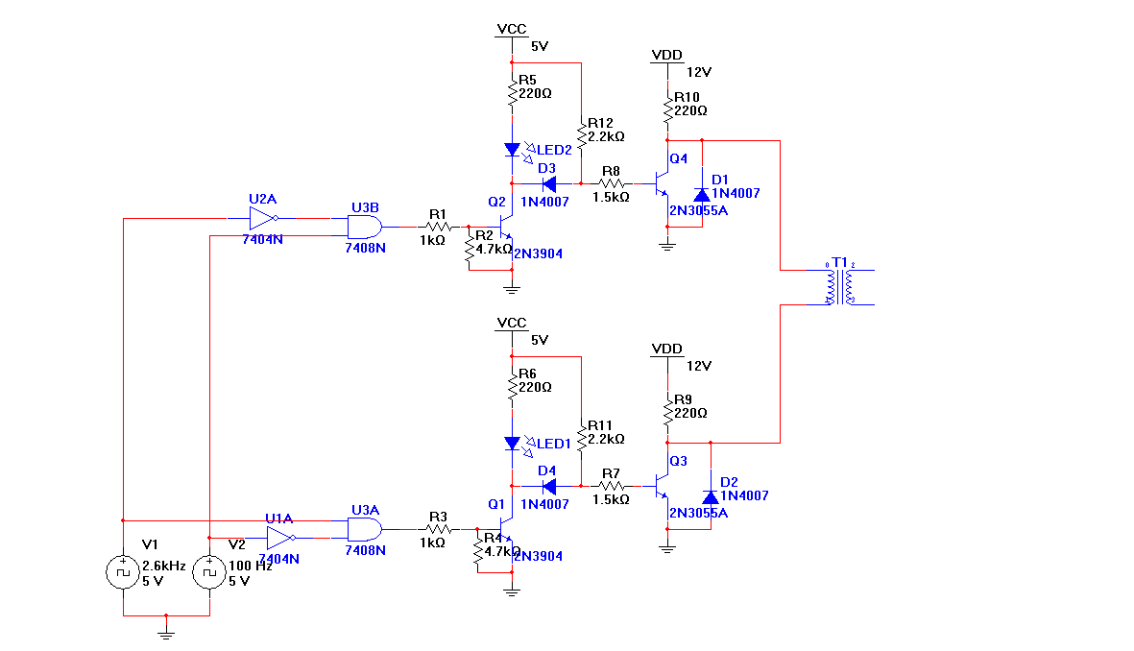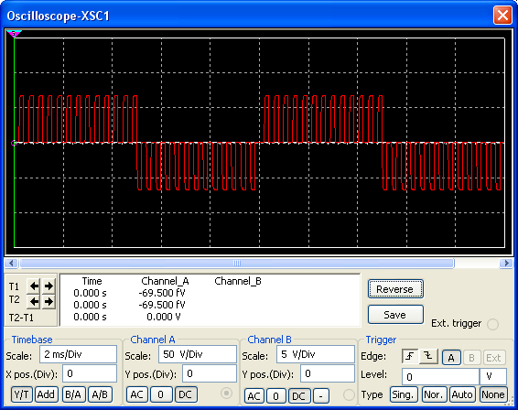

Thanks for the info Tony.
It looks good in theory, but in reality that circuit does not work.
The Meyer waveform, I believe, should be channel A on, then both channels off, then channel B on, then both channels off, etc.
When breadboarded, your circuit only produces short spikes which occur at the same time.
Also, shouldn't there be a diode on the secondary of the output coil?
We have to start somewhere - I need to determine the relationship of the two complementary transistor driver circuit.
I think this may hold the key.
We can generate khz square waves quite easily with 555 timers.
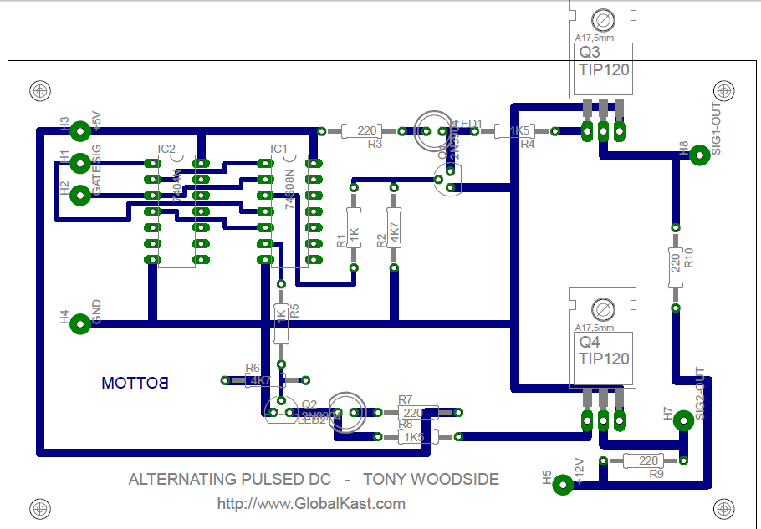
Wow, thanks for that info.
The waveform I get is channel A is on 4x as long as channel B.
At least it does alternate now though.
I still do not get anything happening at the cell though.
Right now I am so frustrated I think the only way to get the water to do anything is to drive two 40kv flyback transformers on and off and shock the water with it.
I'm sure that may cause an effect of some type ;)

All the other things I have tried have failed, and I think the voltage just isn't enough.
What kind of transformer are you using - a step-up?
I used a primary of approx. 600 turns to a secondary of 3500 turns - no effect.
I also tried a primary of approx. 600T and secondary of 5500 turns - no effect.
I also tried with and without a diode on the secondary - no effect.
It's no wonder most people say this is all bunk - so far, it appears to be.
The average experimenter would have given up on all this decades ago.
If only we had Stan's devices to examine...
I think that's because it's like what Steve Meyer said "It's a tuned system". If a single one of the many different parameters of the circuit are not correct it will not work....At least for the VIC and resonant cavity....Not sure if the steam resonator is the same. The use of the driving circuitry of the steam resonator coil being identical to the resonant cavity driving circuitry seems to suggest i

Note there is a Time space between the altenate pulses
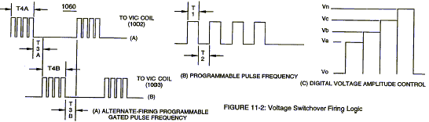

Circuit explained:
The transistors are configured as an H-bridge.
This series of transistors will take 400 volts.
T1 is a 1:10 step-up. T2 is the choke coils bifilar wrapped similar to the 8XA.
The bridge diodes should act as the blocking diode.
The CD4047 will deliver a near perfect 50/50 pulse.
The only thing I’m not sure of is the value of the bias resistors for the transistors,
and the overall frequencies.
I plan on winding the coils on a large ferrite U core, probably with 18 gauge wire.

I think Meyer's water heating is more along the lines of using electrostatic forces to cause oscillation, about the same way a microwave does. Personally I think those patents are right on, but they don't provide any diagrams. The explanation they give though fits right in with Meyer's. I think the only difference is Meyer used resonance to reduce the power requirements.
Don stated the steam resonator driver circuit was the exact same as all the circuits used to drive the resonant cavities.
From the picture we know the steam resonator VIC (the buggy one) had 3 seperate coils, so we have a primary coil, a secondary coil, and a pulse pickup coil.
I tend to think the primary coil is the one connected to the FWB since it is the heaviest gauge. And the secondary coil is connected to the NPN/PNP transistors. The connections from the transistors to the steam resonator tubes are not there. I think the wire ends not connected to anything are the pulse pickup coil. I think the FWB may have been used to protect the primary driving transistor from HV spikes but in that case I wonder why regular diodes weren't just used?

will start with the steam res vic coils
trying to figure out how its wound, there are two different pics available,
i've put on some red/blue/green lines to show what I'm guessing are the different windings
red lines= primary 18turns thick wire
blue lines= secondary1 360turns thin wire
green lines= secondary 2 360turns thin wire

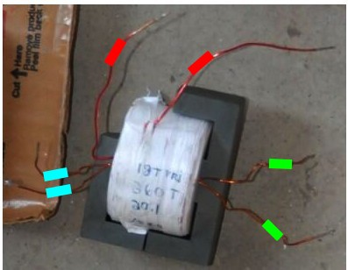
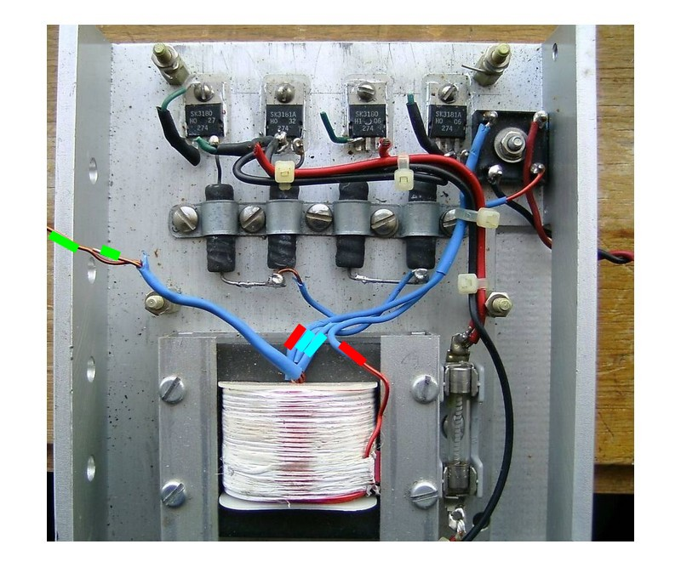
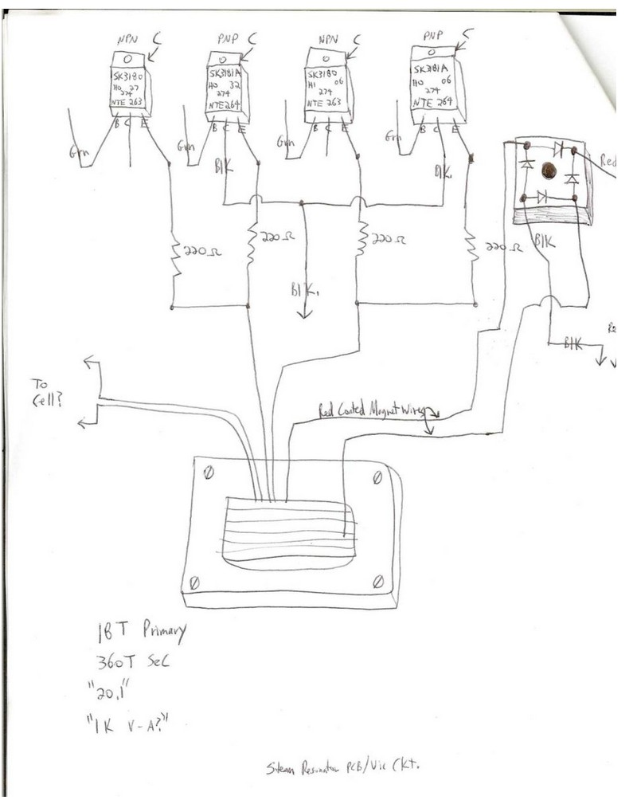
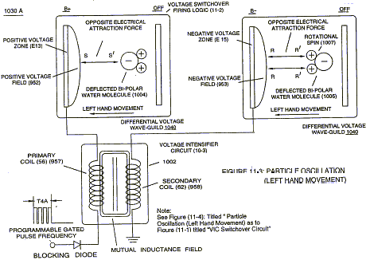
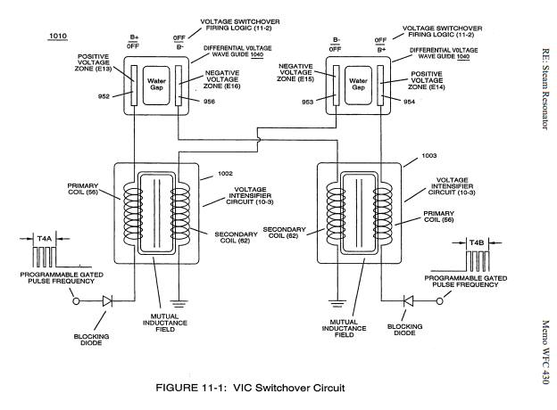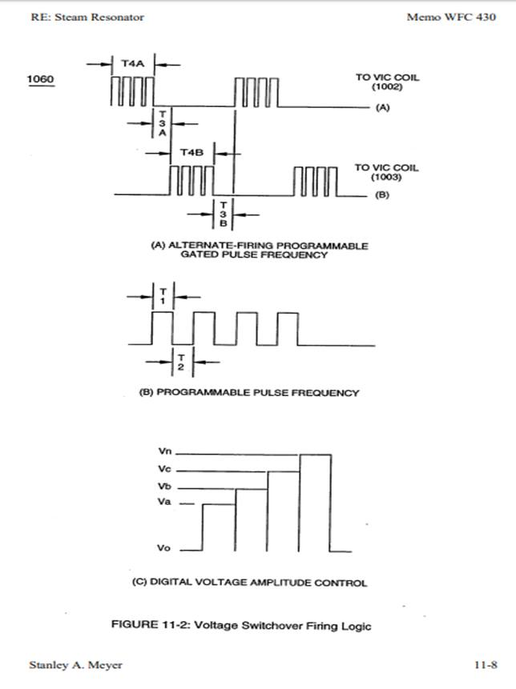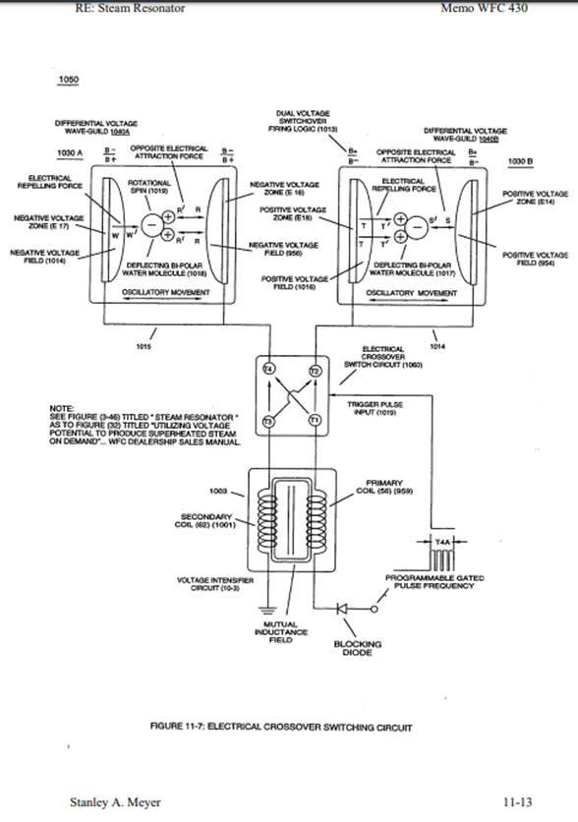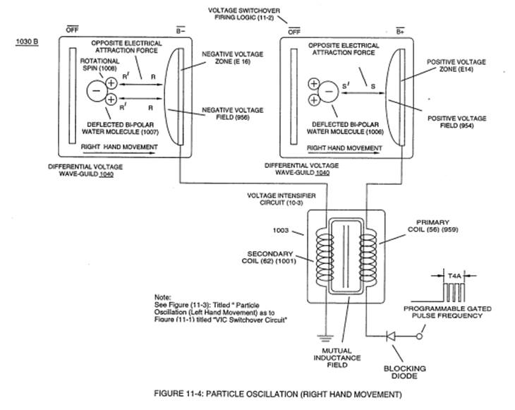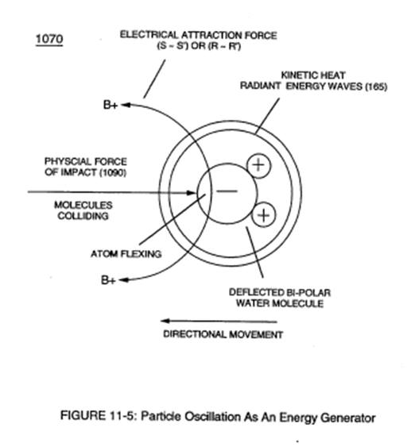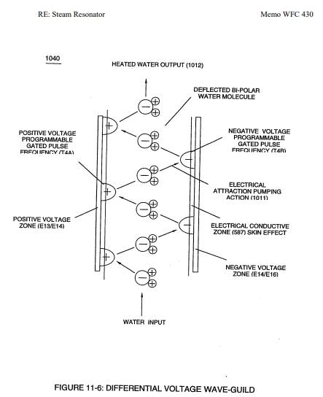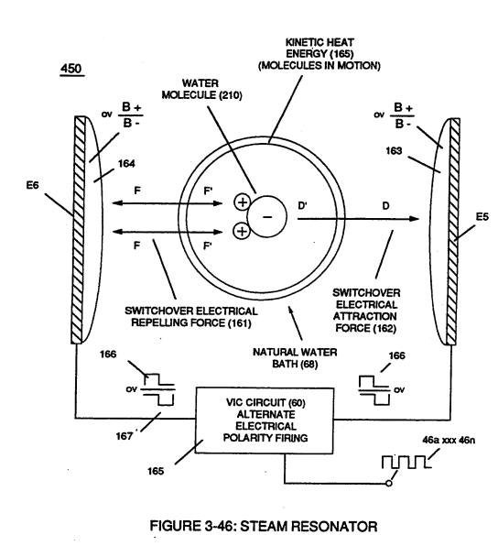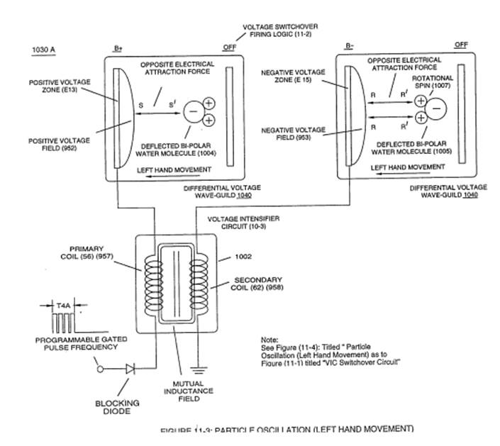
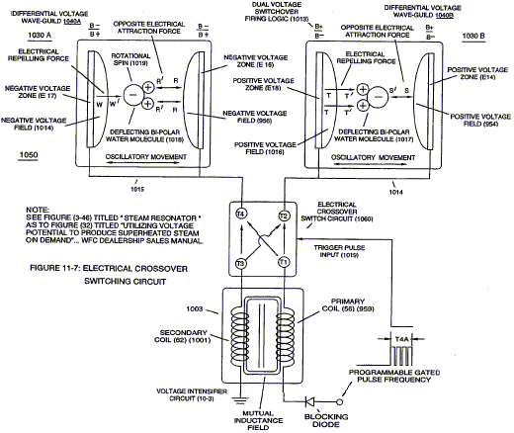
H Bridge
below is a circuit from valyonpz youtube video ( I realise there were some issue with him? on the forum in the past) but for a novice ( i.e. me) these circuits seem to be a good place to start to figure out a replication. This circuit seems to be related to the switching circuit board.
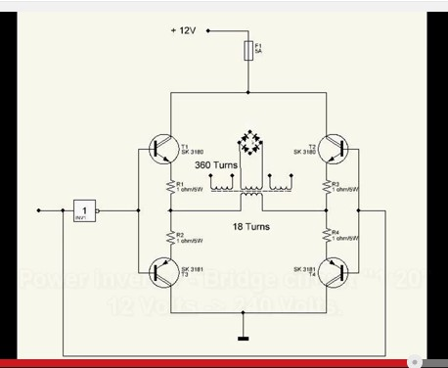

and this one from valyonpz might be related to the pulsing circuit using optocouplers as in stans memo
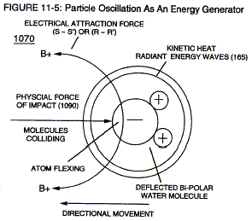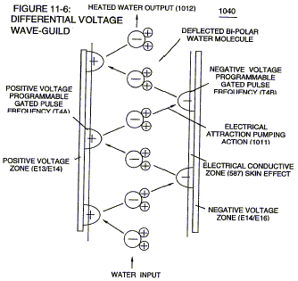

ANNEX

and heres a pic of stans control unit showing steam resonator control board
( which appears identical to the resonant cavity control sections)...suggesting either it uses same pulse circuit for steam res as the resonant cavities ( hho tubes) or he just used the same control panel for steam res for convenience ( I would guess its using same pulse circuit as stans work was very clean/finished design).
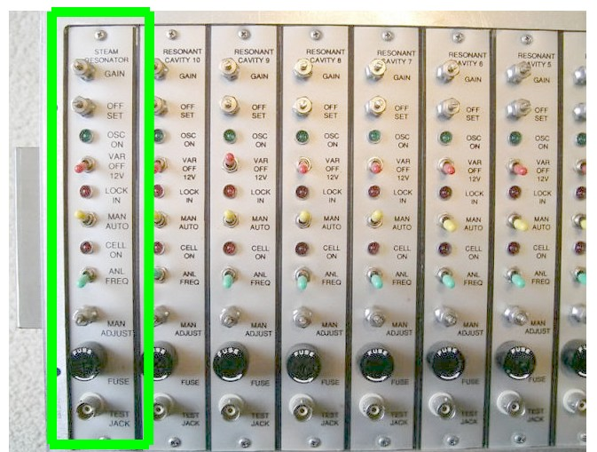

one more pic showing two connections for steam resonator on the resonant cavity,
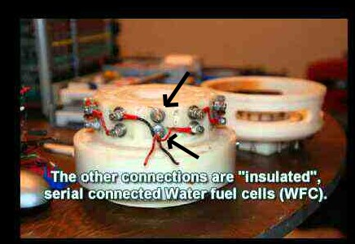

so is it possible to reverse engineer/replicate stans water heater from this information?
Is there enough information to do it?
I realise their are two videos on the net showing replications ( waterenergy1 and irondmax) but seems no detailed information with the vids that would aid reverse engineering).
There are other threads on other forums on this topic but seems no-one has given a replicatible circuit. I've included valyonpz circuits as they the only ones I've been able to find that are related to replicating what evidence there is of stans device.

there is another view of steam res switching board with coil attached
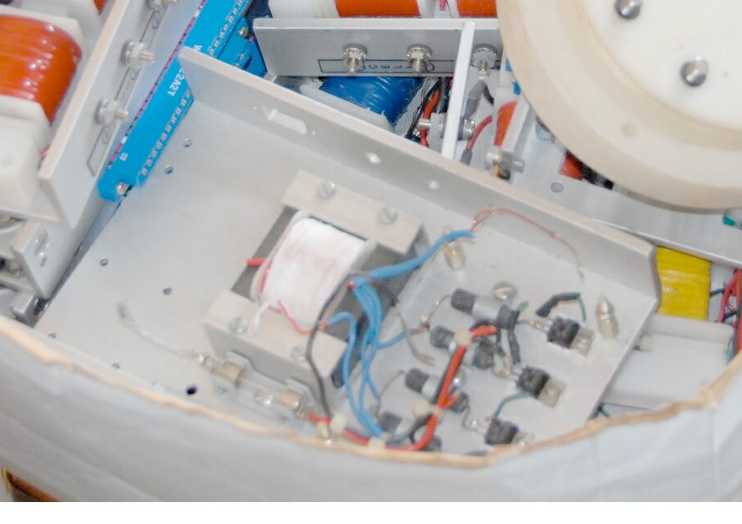

in this pic I've added some dots which represent unknown connections
2 purple dots = two earthing? wires been cut
2 red dots = two thick red wires cut
4 green dots = transistor earth wires been cut
1 red dot (bottom of fuse) /one black dot ( bottom right in pic)= wire connections unknown
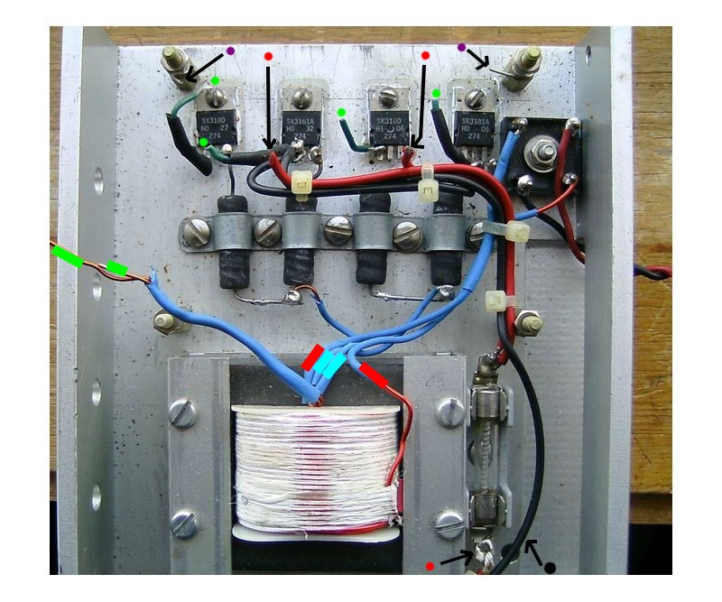
pic attached reverse engineered circuit someone? posted, some missing bits included
fuse and two red wires unattached at top of fuse
bottom of fuse red wire not attached
4 green earths not attached to anything
2 purple dots earth? wires cut
The rectifying diode suggests an ac current was being changed to dc before going into the primary
( possibly from alternator three phase output?) but where was the pulsing dc being produced i.e tank circuit with resonant frequency, was that even used in this circuit?

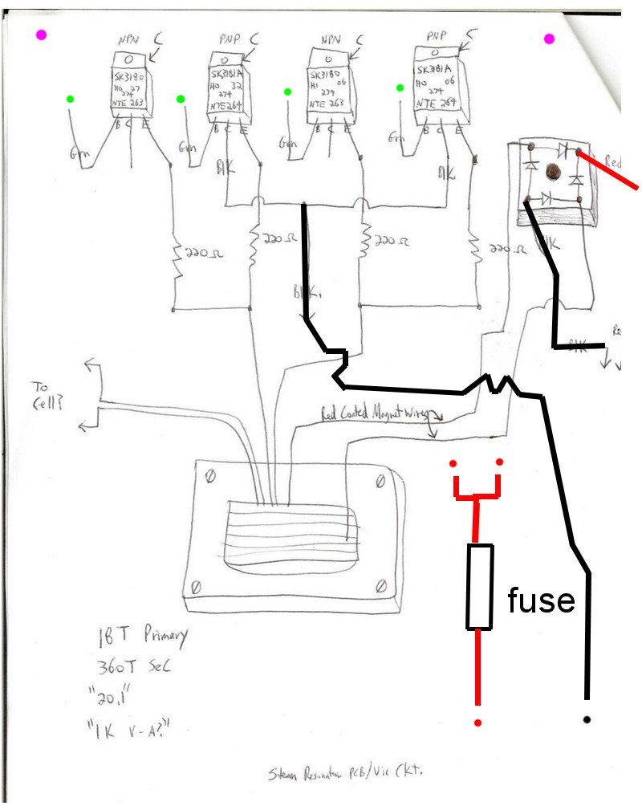

close up view showing heatsink pad had previously been used behind the transistors,
now each transistor is just heatpaste so each has centretap connected to aluminium backplate.
Poses the question, has stan modified the circuit to be simpler after building it, which may explain the two red wires not connected to transistors or has he deliberatley removed the heatsinks to make reverse engineer more difficult?

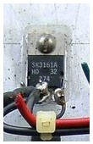
https://www.youtube.com/watch?v=SgpcBRbnyTE#ws
apparently the device i've been posting on, its simply the power supply for the steam resonator,
it converts 12v to 240v.............doh!
that would mean the optocoupler circuit he gives attached would be the thing to concentrate efforts on, he makes note at end of video about pulsing timing.
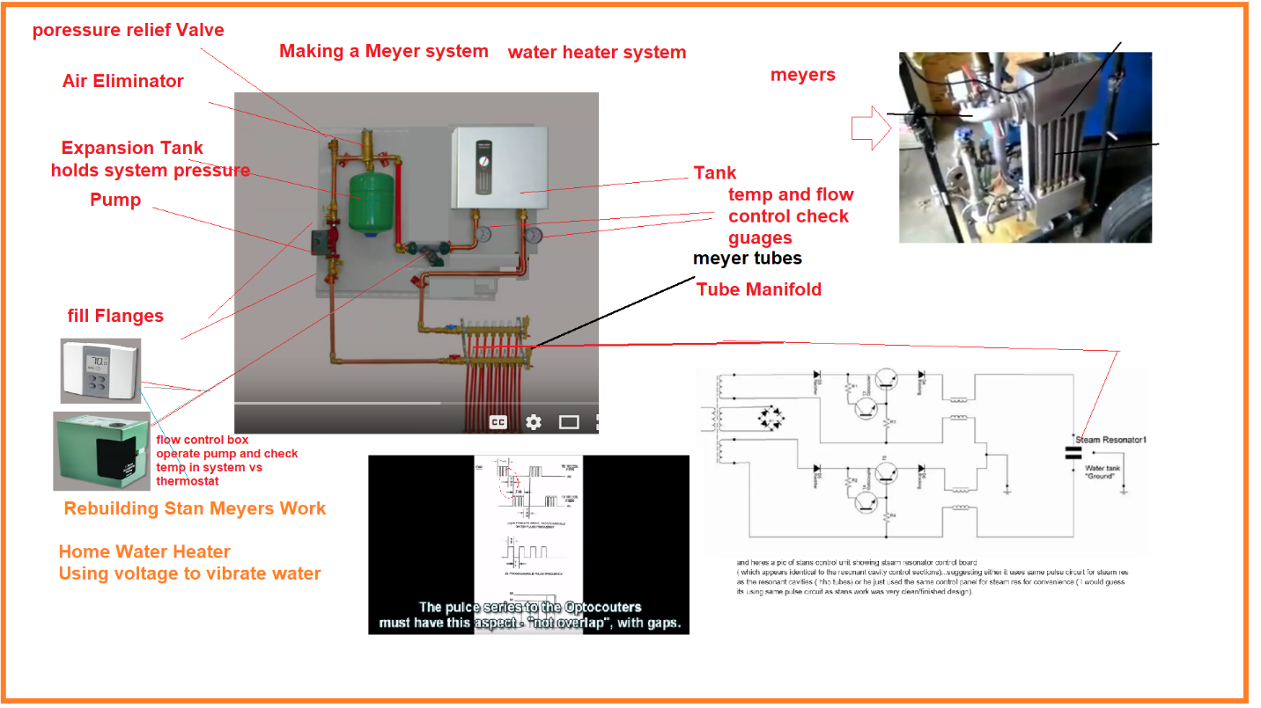

H Bridge
